项目简介
这是一个使用 OpenGL 和 C++ 实现的日地月三体运动可视化项目。
主要功能包括：太阳、地球、月亮球体绘制，椭圆轨道动画，三体自转与公转，摄像机视角控制，纹理贴图与光照效果，支持自发光太阳和多光源高亮显示。

运行截图
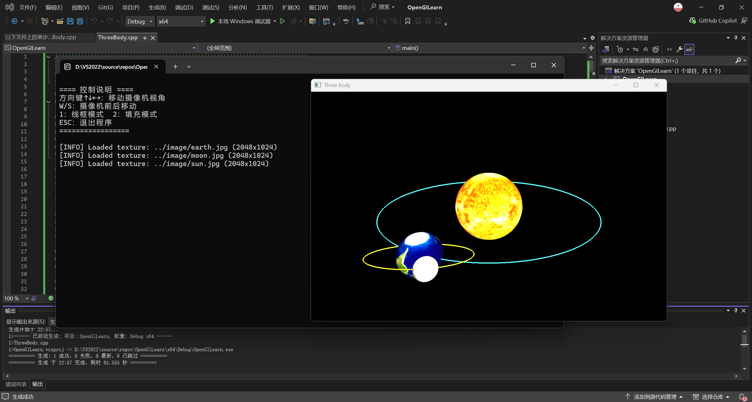
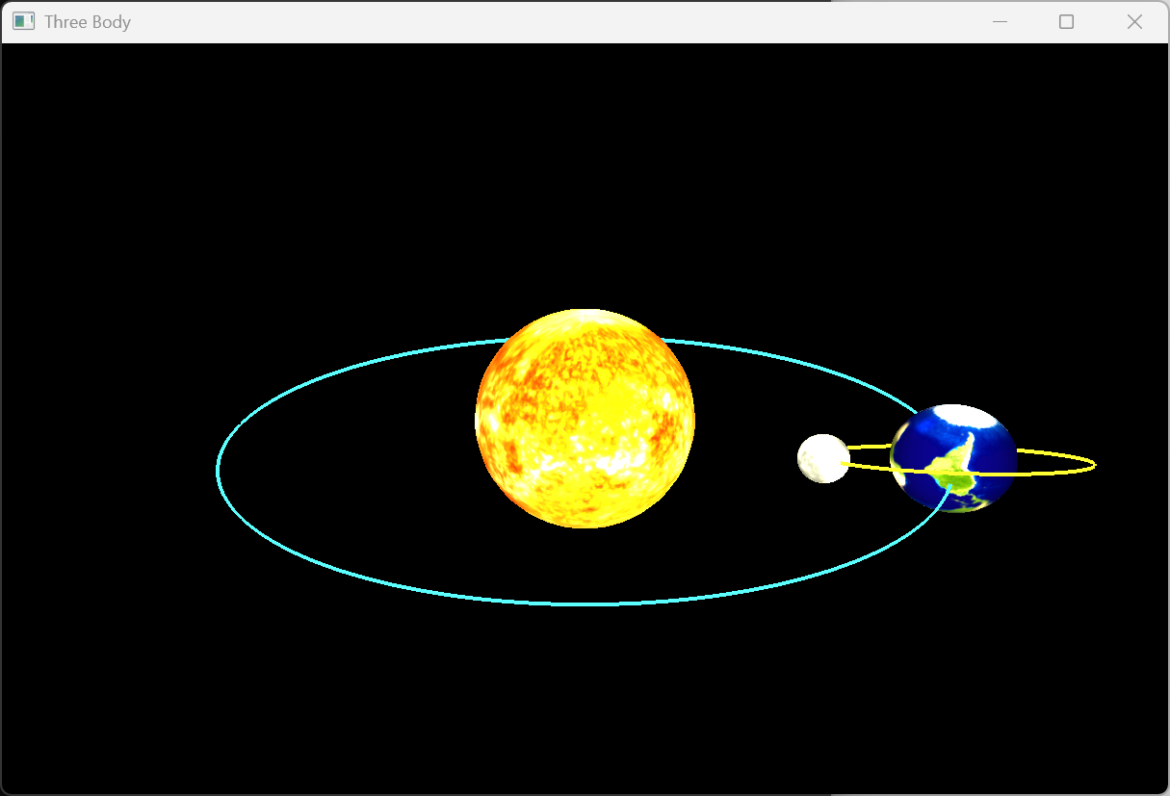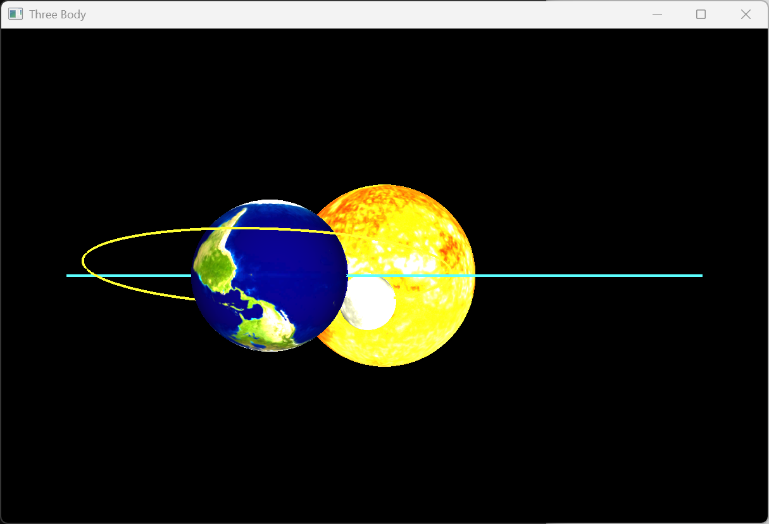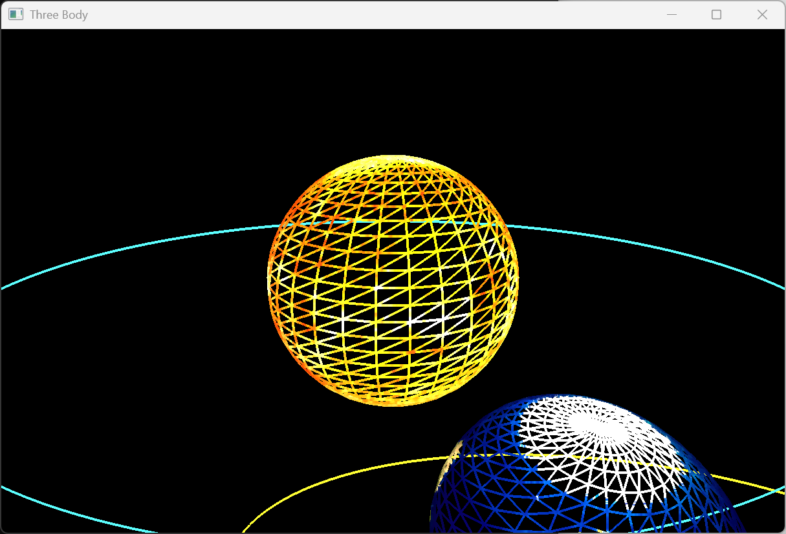

源代码
//////////////////////////////////////////////////////////////////////////////
// ThreeBody.cpp
// 日地月运动模型（三体均有纹理 + 光照 + 自发光太阳）
//////////////////////////////////////////////////////////////////////////////

#define STB_IMAGE_IMPLEMENTATION
#include "stb/stb_image.h"

#include <glad/glad.h>
#include <GLFW/glfw3.h>
#include <iostream>
#include <vmath.h>
#include <vector>
#include <cmath>

const unsigned int SCR_WIDTH = 800;
const unsigned int SCR_HEIGHT = 600;
float aspact = (float)4.0f / (float)3.0f;

float camX = 0.0f, camY = 6.0f, camZ = 12.0f;

std::vector<float> sphereVertices; // pos(3) + normal(3) + tex(2)
std::vector<unsigned int> sphereIndices;
std::vector<float> earthOrbitVertices;
std::vector<float> moonOrbitVertices;

GLuint VAO_sphere, VBO_sphere, EBO_sphere;
GLuint VAO_earthOrbit, VBO_earthOrbit;
GLuint VAO_moonOrbit, VBO_moonOrbit;

GLuint earthTexture = 0, moonTexture = 0, sunTexture = 0;
GLuint shader_program;

const int Y_SEGMENTS = 30;
const int X_SEGMENTS = 30;
const int ORBIT_SEGMENTS = 256;
const GLfloat PI = 3.14159265358979323846f;

// ———————————————————————— 工具函数 ————————————————————————
GLuint loadTexture(const char* path) {
GLuint textureID;
glGenTextures(1, &textureID);
glBindTexture(GL_TEXTURE_2D, textureID);
glTexParameteri(GL_TEXTURE_2D, GL_TEXTURE_WRAP_S, GL_REPEAT);
glTexParameteri(GL_TEXTURE_2D, GL_TEXTURE_WRAP_T, GL_REPEAT);
glTexParameteri(GL_TEXTURE_2D, GL_TEXTURE_MIN_FILTER, GL_LINEAR_MIPMAP_LINEAR);
glTexParameteri(GL_TEXTURE_2D, GL_TEXTURE_MAG_FILTER, GL_LINEAR);

int width, height, nrChannels;
unsigned char* data = stbi_load(path, &width, &height, &nrChannels, 0);
if (data) {
GLenum format = (nrChannels == 4) ? GL_RGBA : GL_RGB;
glTexImage2D(GL_TEXTURE_2D, 0, GL_RGB, width, height, 0, format, GL_UNSIGNED_BYTE, data);
glGenerateMipmap(GL_TEXTURE_2D);
std::cout << "[INFO] Loaded texture: " << path << " (" << width << "x" << height << ")" << std::endl;
}
else {
std::cout << "[WARNING] Failed to load texture: " << path << std::endl;
}
stbi_image_free(data);
return textureID;
}

void print_controls() {
std::cout << "\n==== 控制说明 ====" << std::endl;
std::cout << "方向键↑↓←→：移动摄像机视角" << std::endl;
std::cout << "W/S：摄像机前后移动" << std::endl;
std::cout << "1：线框模式 2：填充模式" << std::endl;
std::cout << "ESC：退出程序" << std::endl;
std::cout << "=================\n" << std::endl;
}

// ———————————————————————— 初始化 ————————————————————————
void initial(void)
{
// 生成球体（带法线+纹理坐标）
const float earthA = 6.0f * 1.3f, earthB = 4.5f * 1.3f;
sphereVertices.clear();
for (int y = 0; y <= Y_SEGMENTS; y++) {
for (int x = 0; x <= X_SEGMENTS; x++) {
float xSegment = (float)x / (float)X_SEGMENTS;
float ySegment = (float)y / (float)Y_SEGMENTS;
float xPos = std::cos(xSegment * 2.0f * PI) * std::sin(ySegment * PI);
float yPos = std::cos(ySegment * PI);
float zPos = std::sin(xSegment * 2.0f * PI) * std::sin(ySegment * PI);
float nx = xPos, ny = yPos, nz = zPos;
float u = xSegment;
float v = 1.0f - ySegment; // 翻转V

sphereVertices.insert(sphereVertices.end(), {
xPos, yPos, zPos,
nx, ny, nz,
u, v
});
}
}

// 修复绕向：确保正面朝外
sphereIndices.clear();
for (int i = 0; i < Y_SEGMENTS; i++) {
for (int j = 0; j < X_SEGMENTS; j++) {
unsigned int a = i * (X_SEGMENTS + 1) + j;
unsigned int b = (i + 1) * (X_SEGMENTS + 1) + j;
unsigned int c = (i + 1) * (X_SEGMENTS + 1) + j + 1;
unsigned int d = i * (X_SEGMENTS + 1) + j + 1;
// 逆时针顺序
sphereIndices.push_back(a); sphereIndices.push_back(c); sphereIndices.push_back(b);
sphereIndices.push_back(a); sphereIndices.push_back(d); sphereIndices.push_back(c);
}
}

// Sphere VAO
glGenVertexArrays(1, &VAO_sphere);
glGenBuffers(1, &VBO_sphere);
glGenBuffers(1, &EBO_sphere);
glBindVertexArray(VAO_sphere);
glBindBuffer(GL_ARRAY_BUFFER, VBO_sphere);
glBufferData(GL_ARRAY_BUFFER, sphereVertices.size() * sizeof(float), sphereVertices.data(), GL_STATIC_DRAW);
glBindBuffer(GL_ELEMENT_ARRAY_BUFFER, EBO_sphere);
glBufferData(GL_ELEMENT_ARRAY_BUFFER, sphereIndices.size() * sizeof(unsigned int), sphereIndices.data(), GL_STATIC_DRAW);
glVertexAttribPointer(0, 3, GL_FLOAT, GL_FALSE, 8 * sizeof(float), (void*)0);
glEnableVertexAttribArray(0);
glVertexAttribPointer(1, 3, GL_FLOAT, GL_FALSE, 8 * sizeof(float), (void*)(3 * sizeof(float)));
glEnableVertexAttribArray(1);
glVertexAttribPointer(2, 2, GL_FLOAT, GL_FALSE, 8 * sizeof(float), (void*)(6 * sizeof(float)));
glEnableVertexAttribArray(2);
glBindVertexArray(0);

// 地球轨道
earthOrbitVertices.clear();
for (int i = 0; i < ORBIT_SEGMENTS; ++i) {
float theta = (float)i / ORBIT_SEGMENTS * 2.0f * PI;
earthOrbitVertices.push_back(earthA * std::cos(theta));
earthOrbitVertices.push_back(0.0f);
earthOrbitVertices.push_back(earthB * std::sin(theta));
}
glGenVertexArrays(1, &VAO_earthOrbit);
glGenBuffers(1, &VBO_earthOrbit);
glBindVertexArray(VAO_earthOrbit);
glBindBuffer(GL_ARRAY_BUFFER, VBO_earthOrbit);
glBufferData(GL_ARRAY_BUFFER, earthOrbitVertices.size() * sizeof(float), earthOrbitVertices.data(), GL_STATIC_DRAW);
glVertexAttribPointer(0, 3, GL_FLOAT, GL_FALSE, 3 * sizeof(float), (void*)0);
glEnableVertexAttribArray(0);
glBindVertexArray(0);

// 月亮轨道（带倾角）
const float moonA = 2.0f * 1.3f, moonB = 1.2f * 1.3f, moonTiltDeg = 20.0f;
float tiltRad = moonTiltDeg * PI / 180.0f;
moonOrbitVertices.clear();
for (int i = 0; i < ORBIT_SEGMENTS; ++i) {
float theta = (float)i / ORBIT_SEGMENTS * 2.0f * PI;
float x = moonA * std::cos(theta);
float z = moonB * std::sin(theta);
float y = z * std::sin(tiltRad);
float z_tilted = z * std::cos(tiltRad);
moonOrbitVertices.insert(moonOrbitVertices.end(), { x, y, z_tilted });
}
glGenVertexArrays(1, &VAO_moonOrbit);
glGenBuffers(1, &VBO_moonOrbit);
glBindVertexArray(VAO_moonOrbit);
glBindBuffer(GL_ARRAY_BUFFER, VBO_moonOrbit);
glBufferData(GL_ARRAY_BUFFER, moonOrbitVertices.size() * sizeof(float), moonOrbitVertices.data(), GL_STATIC_DRAW);
glVertexAttribPointer(0, 3, GL_FLOAT, GL_FALSE, 3 * sizeof(float), (void*)0);
glEnableVertexAttribArray(0);
glBindVertexArray(0);

// 着色器
const char* vertexShaderSource = R"(
#version 330 core
layout (location = 0) in vec3 aPos;
layout (location = 1) in vec3 aNormal;
layout (location = 2) in vec2 aTexCoord;
out vec3 FragPos;
out vec3 Normal;
out vec2 TexCoord;
uniform mat4 transform;
void main()
{
FragPos = vec3(transform * vec4(aPos, 1.0));
Normal = mat3(transpose(inverse(mat3(transform)))) * aNormal;
TexCoord = aTexCoord;
gl_Position = transform * vec4(aPos, 1.0);
}
)";

const char* fragmentShaderSource = R"(
#version 330 core
in vec3 FragPos;
in vec3 Normal;
in vec2 TexCoord;
out vec4 FragColor;
uniform sampler2D diffuseTexture;
uniform vec3 lightPos1;
uniform vec3 lightPos2;
uniform vec3 viewPos;
uniform bool useTexture;
uniform bool isEmissive;
uniform vec3 objectColor;

vec3 calculateLight(vec3 lightPos, vec3 fragPos, vec3 normal, vec3 viewDir, vec3 color) {
vec3 lightColor = vec3(1.2, 1.2, 1.0); // 更亮的光源
vec3 ambient = 0.5 * lightColor; // 环境光更强
vec3 lightDir = normalize(lightPos - fragPos);
float diff = max(dot(normal, lightDir), 0.0);
vec3 diffuse = diff * lightColor;
vec3 reflectDir = reflect(-lightDir, normal);
float spec = pow(max(dot(viewDir, reflectDir), 0.0), 32);
vec3 specular = spec * lightColor;
return (ambient + diffuse + specular) * color;
}

void main()
{
vec3 color = useTexture ? texture(diffuseTexture, TexCoord).rgb : objectColor;
if (isEmissive) {
FragColor = vec4(color, 1.0);
return;
}
vec3 norm = normalize(Normal);
vec3 viewDir = normalize(viewPos - FragPos);
vec3 result = calculateLight(lightPos1, FragPos, norm, viewDir, color);
result += calculateLight(lightPos2, FragPos, norm, viewDir, color);
FragColor = vec4(result, 1.0);
}
)";

// 编译着色器
int success; char infoLog[512];
GLuint vs = glCreateShader(GL_VERTEX_SHADER);
glShaderSource(vs, 1, &vertexShaderSource, NULL);
glCompileShader(vs);
glGetShaderiv(vs, GL_COMPILE_STATUS, &success);
if (!success) {
glGetShaderInfoLog(vs, 512, NULL, infoLog);
std::cout << "Vertex shader compilation failed:\n" << infoLog << std::endl;
}

GLuint fs = glCreateShader(GL_FRAGMENT_SHADER);
glShaderSource(fs, 1, &fragmentShaderSource, NULL);
glCompileShader(fs);
glGetShaderiv(fs, GL_COMPILE_STATUS, &success);
if (!success) {
glGetShaderInfoLog(fs, 512, NULL, infoLog);
std::cout << "Fragment shader compilation failed:\n" << infoLog << std::endl;
}

shader_program = glCreateProgram();
glAttachShader(shader_program, vs);
glAttachShader(shader_program, fs);
glLinkProgram(shader_program);
glGetProgramiv(shader_program, GL_LINK_STATUS, &success);
if (!success) {
glGetProgramInfoLog(shader_program, 512, NULL, infoLog);
std::cout << "Shader program linking failed:\n" << infoLog << std::endl;
}
glDeleteShader(vs);
glDeleteShader(fs);

glUseProgram(shader_program);

// 加载纹理
earthTexture = loadTexture("../image/earth.jpg");
moonTexture = loadTexture("../image/moon.jpg");
sunTexture = loadTexture("../image/sun.jpg");

// OpenGL 状态
glLineWidth(4.0f); // 轨道线宽
glEnable(GL_DEPTH_TEST);
glEnable(GL_CULL_FACE);
glCullFace(GL_BACK);
}

// ———————————————————————— 渲染循环 ————————————————————————
void Draw(void)
{
glClearColor(0.0f, 0.0f, 0.0f, 1.0f);
glClear(GL_COLOR_BUFFER_BIT | GL_DEPTH_BUFFER_BIT);

vmath::mat4 view = vmath::lookat(vmath::vec3(camX, camY, camZ), vmath::vec3(0), vmath::vec3(0, 1, 0));
vmath::mat4 proj = vmath::perspective(60.0f, aspact, 1.0f, 500.0f);

glUseProgram(shader_program);
GLuint transformLoc = glGetUniformLocation(shader_program, "transform");
GLuint useTextureLoc = glGetUniformLocation(shader_program, "useTexture");
GLuint isEmissiveLoc = glGetUniformLocation(shader_program, "isEmissive");
GLuint objectColorLoc = glGetUniformLocation(shader_program, "objectColor");
GLuint textureLoc = glGetUniformLocation(shader_program, "diffuseTexture");
GLuint lightPos1Loc = glGetUniformLocation(shader_program, "lightPos1");
GLuint lightPos2Loc = glGetUniformLocation(shader_program, "lightPos2");
GLuint viewPosLoc = glGetUniformLocation(shader_program, "viewPos");

// 光源：太阳位置 + 背光灯
glUniform3f(lightPos1Loc, 0.0f, 0.0f, 0.0f);
glUniform3f(lightPos2Loc, 6.0f, 6.0f, -6.0f);
glUniform3f(viewPosLoc, camX, camY, camZ);

float t = (float)glfwGetTime();
const float earthA = 6.0f * 1.3f, earthB = 4.5f * 1.3f;
const float moonA = 2.0f * 1.3f, moonB = 1.2f * 1.3f, moonTiltDeg = 20.0f;
const float earthPeriod = 20.0f;
const float moonPeriod = 2.0f;
float tiltRad = moonTiltDeg * PI / 180.0f;

// —————— 太阳 ——————
// 太阳光源：主光源在原点，补光灯在右后上方
glUniform3f(lightPos1Loc, 0.0f, 0.0f, 0.0f);
glUniform3f(lightPos2Loc, 6.0f, 6.0f, -6.0f);
glUniform3f(viewPosLoc, camX, camY, camZ);
vmath::mat4 sunTrans = proj * view * vmath::scale(2.5f);
glUniformMatrix4fv(transformLoc, 1, GL_FALSE, sunTrans);
glUniform1i(isEmissiveLoc, false); // 太阳参与光照
if (sunTexture) {
glUniform1i(useTextureLoc, true);
glActiveTexture(GL_TEXTURE0);
glBindTexture(GL_TEXTURE_2D, sunTexture);
glUniform1i(textureLoc, 0);
}
else {
glUniform1i(useTextureLoc, false);
glUniform3f(objectColorLoc, 1.8f, 1.8f, 0.8f); // 太阳颜色更亮
}
glBindVertexArray(VAO_sphere);
glDrawElements(GL_TRIANGLES, (unsigned int)sphereIndices.size(), GL_UNSIGNED_INT, 0);

// —————— 地球轨道 ——————
glUniform3f(lightPos1Loc, 0.0f, 0.0f, 0.0f);
glUniform3f(lightPos2Loc, 0.0f, 0.0f, -10.0f);
glUniform3f(viewPosLoc, camX, camY, camZ);
vmath::mat4 orbitTrans = proj * view;
glUniformMatrix4fv(transformLoc, 1, GL_FALSE, orbitTrans);
glUniform1i(isEmissiveLoc, false);
glUniform1i(useTextureLoc, false);
glUniform3f(objectColorLoc, 0.3f, 0.9f, 1.0f); // 青蓝色
glBindVertexArray(VAO_earthOrbit);
glDrawArrays(GL_LINE_LOOP, 0, ORBIT_SEGMENTS);

// —————— 地球 ——————
float angEarth = -t * (2.0f * PI / earthPeriod);
float earthX = earthA * std::cos(angEarth);
float earthZ = earthB * std::sin(angEarth);
vmath::mat4 earthTrans = proj * view * vmath::translate(earthX, 0.0f, earthZ) * vmath::scale(1.1f);
glUniformMatrix4fv(transformLoc, 1, GL_FALSE, earthTrans);
glUniform1i(isEmissiveLoc, false);
if (earthTexture) {
glUniform1i(useTextureLoc, true);
glActiveTexture(GL_TEXTURE0);
glBindTexture(GL_TEXTURE_2D, earthTexture);
glUniform1i(textureLoc, 0);
}
else {
glUniform1i(useTextureLoc, false);
glUniform3f(objectColorLoc, 0.2f, 0.6f, 1.0f);
}
glBindVertexArray(VAO_sphere);
glDrawElements(GL_TRIANGLES, (unsigned int)sphereIndices.size(), GL_UNSIGNED_INT, 0);

// —————— 月亮轨道 ——————
vmath::mat4 moonOrbitTrans = proj * view * vmath::translate(earthX, 0.0f, earthZ);
glUniformMatrix4fv(transformLoc, 1, GL_FALSE, moonOrbitTrans);
glUniform1i(isEmissiveLoc, false);
glUniform1i(useTextureLoc, false);
glUniform3f(objectColorLoc, 1.0f, 1.0f, 0.2f); // 亮黄色
glBindVertexArray(VAO_moonOrbit);
glDrawArrays(GL_LINE_LOOP, 0, ORBIT_SEGMENTS);

// —————— 月亮 ——————
float angMoon = -t * (2.0f * PI / moonPeriod);
float moonX = moonA * std::cos(angMoon);
float moonZ = moonB * std::sin(angMoon);
float moonY = moonZ * std::sin(tiltRad);
float moonZ_tilted = moonZ * std::cos(tiltRad);
vmath::mat4 moonTrans = proj * view *
vmath::translate(earthX, 0.0f, earthZ) *
vmath::translate(moonX, moonY, moonZ_tilted) *
vmath::scale(0.5f);
glUniformMatrix4fv(transformLoc, 1, GL_FALSE, moonTrans);
if (moonTexture) {
glUniform1i(useTextureLoc, true);
glActiveTexture(GL_TEXTURE0);
glBindTexture(GL_TEXTURE_2D, moonTexture);
glUniform1i(textureLoc, 0);
}
else {
glUniform1i(useTextureLoc, false);
glUniform3f(objectColorLoc, 0.8f, 0.8f, 0.85f);
}
glBindVertexArray(VAO_sphere);
glDrawElements(GL_TRIANGLES, (unsigned int)sphereIndices.size(), GL_UNSIGNED_INT, 0);

glBindVertexArray(0);
}

// ———————————————————————— 回调与主函数 ————————————————————————
void key_callback(GLFWwindow* window, int key, int scancode, int action, int mods)
{
if (action == GLFW_PRESS || action == GLFW_REPEAT) {
switch (key) {
case GLFW_KEY_ESCAPE: glfwSetWindowShouldClose(window, true); break;
case GLFW_KEY_UP: camY += 1.0f; break;
case GLFW_KEY_DOWN: camY -= 1.0f; break;
case GLFW_KEY_LEFT: camX -= 1.0f; break;
case GLFW_KEY_RIGHT: camX += 1.0f; break;
case GLFW_KEY_W: camZ -= 1.0f; break;
case GLFW_KEY_S: camZ += 1.0f; break;
case GLFW_KEY_1: glPolygonMode(GL_FRONT_AND_BACK, GL_LINE); break;
case GLFW_KEY_2: glPolygonMode(GL_FRONT_AND_BACK, GL_FILL); break;
default: break;
}
}
}

void reshaper(GLFWwindow* window, int width, int height)
{
glViewport(0, 0, width, height);
aspact = (height == 0) ? (float)width : (float)width / (float)height;
}

int main()
{
print_controls();
if (!glfwInit()) return -1;

glfwWindowHint(GLFW_CONTEXT_VERSION_MAJOR, 4);
glfwWindowHint(GLFW_CONTEXT_VERSION_MINOR, 4);
glfwWindowHint(GLFW_OPENGL_PROFILE, GLFW_OPENGL_CORE_PROFILE);

GLFWwindow* window = glfwCreateWindow(SCR_WIDTH, SCR_HEIGHT, "Three Body", NULL, NULL);
if (!window) { glfwTerminate(); return -1; }
glfwMakeContextCurrent(window);

if (!gladLoadGLLoader((GLADloadproc)glfwGetProcAddress)) return -1;

initial();
glfwSetFramebufferSizeCallback(window, reshaper);
glfwSetKeyCallback(window, key_callback);

while (!glfwWindowShouldClose(window)) {
Draw();
glfwSwapBuffers(window);
glfwPollEvents();
}

// Cleanup
glDeleteVertexArrays(1, &VAO_sphere);
glDeleteBuffers(1, &VBO_sphere);
glDeleteBuffers(1, &EBO_sphere);
glDeleteVertexArrays(1, &VAO_earthOrbit);
glDeleteBuffers(1, &VBO_earthOrbit);
glDeleteVertexArrays(1, &VAO_moonOrbit);
glDeleteBuffers(1, &VBO_moonOrbit);
glDeleteTextures(1, &earthTexture);
glDeleteTextures(1, &moonTexture);
glDeleteTextures(1, &sunTexture);
glDeleteProgram(shader_program);

glfwDestroyWindow(window);
glfwTerminate();
return 0;
}

